

**MEMORANDUM OF UNDERSTANDING**

This is a document validating an agreement between **MR. OGABOR JOHN AND MRS. BOLA AHMED TINUBU** for the collaborative of 20% interest over a sum of **ONE MILLION NAIRA ONLY (N1000000) paid on the 11th of May, 2020.**

There is a binding agreement to pay the initial capital invested, alongside the interest, **ONE MILLION, TWO HUNDRED THOUSAND NAIRA ONLY (N1200000) on the 10th of June, 2020** by **MR. OGABOR JOHN TO MRS. BOLA AHMED TINUBU.**

Attached with this document is an evidence of payment by **MRS. BOLA AHMED TINUBU.**

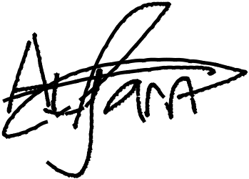

_________________________

_~~__~~_____~~___~~_~~_~~___________



**MRS. BOLA AHMED TINUBU**

**MR. OGABOR JOHN**

***(CEO, JOHN INVESTMENTS)***